**I Love You Man (or Boy)!**

Mark Burkle/Justin Storey/Kyle Lindberg

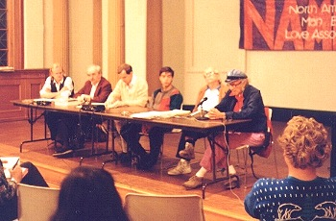

**Introduction**

Around the world and the large universe of the World Wide Web, homosexuality is thought about in many different ways and perspectives. If a person types in homosexual, fag, or gay in Google or any other search engine, they will get many different responses. Some responses will be definitions of such words, but most will be pro-homosexual or anti-homosexual links.

The North American Man/Boy Love Association (NAMBLA) was formed in 1978. It was inspired by the success of a campaign based in Boston's gay community to defend against a local witch-hunt.NAMBLA's goal is to end the extreme oppression of men and boys in mutually “consensual relationships” by:

* building understanding and support for such relationships;
* educating the general public on the benevolent nature of man/boy love;
* cooperating with lesbian, gay, feminist, and other liberation movements;
* supporting the liberation of persons of all ages from sexual prejudice and oppression (<http://nambla.org/welcome.htm>)

The NAMBLA mission statement is as follows:

“We call for fundamental reform of the laws regarding relations between youths and adults. Today, many thousands of men and boys are unjustly ground into the dysfunctional criminal justice system. Blindly, this system condemns consensual, loving relationships between younger and older people. NAMBLA's Prisoner Program, with limited resources, works to provide a modicum of humanity to some of these people. (<http://nambla.org/welcome.htm>)”

**Research Objectives**

The purpose of this research is to analyze each link of this website ([www.nambla.org](http://www.nambla.org)). We expect to explain their purpose of what they are trying to accomplish. Understanding what this organization is all about is a very complex idea as we strive to find out what kind of influence this website has had on the gay right’s issues and liberation movements of its kind. The NAMBLA organization fights a two-fold path in that it argues for both homosexuality as well as molestation. Gaining influence in the former arena is a must, in order to have hopes of arguing for their parallel society suppression in the later.

**Methodology**

The methodology of this research involves content analysis of the website NAMBLA. We sifted through each link on this website and analyzed what they were trying to say as well as points they were trying to shed light on within the general public. Visual pictures are also included during this content analysis. Investigator triangulation was also achieved as multiple researchers collected, as well as interpreted data.

**Results/Findings**

*Criminalization of Youth*

The first heading on the NAMBLA website, under the heading “Topics,” is titled “The Criminalization of Youth.” As we click on this link we are brought to a new page. This page begins with talking about how the 1960’s was an important time for the development of the youth in America. The 1960’s was seen as a period of time, in which youth began experimenting and taking on new social activities. The page shifts from talking about how great the 1960’s was for young people, to discussing the horrors of the 1980’s. This is a period where the terms “juvenile sex offender” and “teenage super-predator” gained popularity. Sex was portrayed to youth as violent and dangerous. The page goes on to mention how young children have been charged with sex crimes for simply playing “doctor” with one another. Institutions that house these young “sex offenders” are teaching them to look at their own sexuality as bad, and to fear it. At the very bottom the web page are seven individual headings typed in blue print. These headings give examples of the youth who have been housed in institutions for sex crimes. One example is a troubling story of a 10-year-old boy. He was taken from his home by the department of health because he had Asperser’s syndrome and wasn’t doing well in the public school system. While in treatment he had a sexual encounter with another boy. The young boy was moved to a different facility that houses criminal sex offenders.

*Youth Views and Issues*



The second heading on the web page is titled “Youth Views and Issues.” After clicking on this heading a new page comes up with a picture of five older gentlemen and a 16-year-old boy. This is a picture taken from a meeting that consisted of 30 men and two youths. These individuals were meeting to discuss man/boy love. From this very meeting began the formation of NAMBLA. The page informs us that young men play an active role in NAMBLA and speak about why man/boy love should not be scapegoat. NAMBLA also speaks about the injustices youth face in our society and ways to fix them. At the bottom of the page NAMBLA claims that the youth associated with them speak for themselves. Following this statement are seven links to different web pages that discuss what the youth of NAMBLA have published. One of the links is titled “Boy ‘Victim’ Speaks Out.” After clicking on this link a page comes up about one boy’s story. A 14-year-old boy tells of how he was sexually assaulted by a Boy Scout leader (who was much older than he was). The boy doesn’t believe he was sexually assaulted, however, but says he loved the older man. He tells about how he felt mistreated because the older man went to jail and he was told that everything he told a counselor would be confidential. The boy who tells his story is now much older and feels something needs to be done so that young boys and older men can have relationships without the law being in the way. The testimonials are presented in a manner that is positive in nature, in order to fully sell their product of man-boy love. This humanizes the issue at hand which enables the reader to understand what exactly the criminalization is doing to them personally.

*Criminal Injustice System*

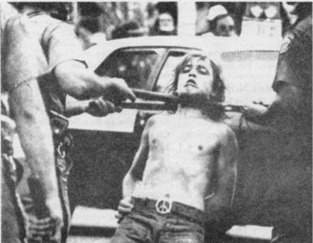

Another heading from the main page of the NAMBLA website is titled “The Criminal Injustice System.” After clicking on this link we are brought to a new web page. The page begins by stating how our current criminal justice system is “criminal.” NAMBLA believes that man/boy relationships are automatically subject to injustices such as prison, therapy, counseling, no parole, and having to register as a sex offender for life. Even if a young boy initiates intimate relations with an older man, the man will be in trouble. The feelings of consent by the boy aren’t considered at all. Once again, there are several links to other web pages at the bottom of this page. These links are all associated with how the criminal justice system is unfair. One of the links is titled “5 to 10.” After clicking on this link a new page appears that discusses a 24-year-old man who wishes to join NAMBLA. The man states he has been affected negatively by the criminal justice system. When he was 13 he had a relationship with an older man. He claims the two were in love and they were sexually active. When his parents found out about the relationship they made him testify against the older man. The boy told the judge that he consented to the relationship. The judge told him he was too young to consent and sentenced the man to 5-10 years in prison. The now 24-year-old man is outraged about how this situation was handled.

*Stories of Man/Boy Love*

A fourth heading from the homepage is titled “Stories of Man/Boy Love.” When we click on this link a new page comes up. The page consists of only two short paragraphs. It says how man/boy relationships have been around for thousands of years. It also states how these relationships have been suppressed by the media. At the bottom of the page are several links to stories about man/boy love. These stories can be fiction and non-fiction. We clicked on the link titled “Molested” and Glad!” A new page pops up where Brian tells his story. Brian was a young boy who had sexual relations with his much older camp counselor. After camp was over Brian never saw the counselor again. Brian says he was not molested but rather “loved.” [Now a gay man in his 30’s, Brian claims he is not attracted to children as his counselor was.]

*Personal Experience*

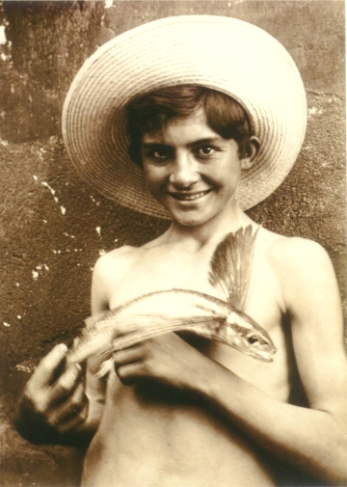

The fifth heading from the left side of NAMBLA’s homepage is titled “Personal Experience.” As we click on this heading we are brought to a new page. Here, there is a picture of a young boy with a hat holding what looks like a fish with wings. NAMBLA starts the page by mentioning how media portrays man/boy love with stereotypes and sensationalism. It also states that media outlets “borrow from traditional witches and demons, then update and embellish as needed” ([www.nambla.org](http://www.nambla.org)). Journalists, professionals, and political figures also embellish on mythology. From all of this stereotyping, NAMBLA claims the public is being brainwashed about what man/boy love actually is. The remedy for this problem is to get first-hand accounts from the people involved in man/boy relationships. At the bottom of this page are several links to other websites that give first-hand accounts of man/boy relationships. We clicked on the link titled “Love is Good.” A new page comes up. Here a man from prison writes a letter to NAMBLA about his personal account. He tells of his relationship with an 8-year-old boy. They were both in love for many years. On the boys 16th birthday they had sex and now the man is in prison. The boy visits him in prison every week. He tells NAMBLA he supports them and that one day, justice will be served to people involved in man/boy relationships.

*Social Issues*

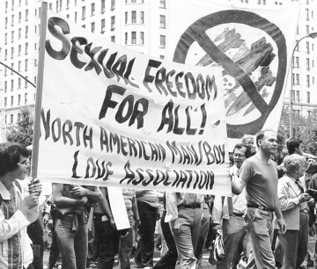

The sixth heading is titled “Social Issues.” After clicking on this blue heading we are directed to a new website. There is a picture a NAMBLA parade where people are holding a large sign in protest. On this page NAMBLA states “Raising awareness and calling attention to social issues is what NAMBLA was founded to do” ([www.nambla.org](http://www.nambla.org)). There isn’t much else to this particular webpage other than the one paragraph. It also talks about how NAMBLA realizes there are injustices to man/boy lovers and wants to correct them. The page states NAMBLA has several articles on homophobic people, gays, and strategies for these types of people.

*Biography*

The seventh heading from NAMBLA’s homepage is titled “Biography.” After clicking on “Biography” we are directed to a new webpage. Here, there are three paragraphs of writing. These paragraphs talk about how several famous people in American history had man/boy relationships. NAMBLA claims this goes to show how widespread man/boy relationships really are.

History

The next heading is about the History of NAMBLA, which talks about cultural institutions, cultural concepts, as well as iconic figures that represents what NAMBLA stands for. The most interesting link (there are several) is headed [“15 Famous Men that loved boys”]. Here there is information about Alexander the Great whom was sent a beautiful young boy as a peace offering. It also talks about such iconic figures as Leonardo Da Vinci and his adopted boy, as well as Michelangelo whom went on to write upwards of 50 poems after the death of a friend’s nephew. The article also goes on to list several other boys that are thought to have been lovers with the great sculptor and painter during his time.

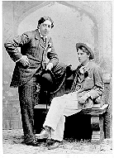To the left you will see a picture of Oscar Wilde and Lord Alfred Douglas. Wilde was an Irish dramatist that bragged about having five different boys within a single night. He talks about how he had a passion for lower class boys as they “were all body with no soul” and the fact that they were all so dirty/unclean really appealed to him.

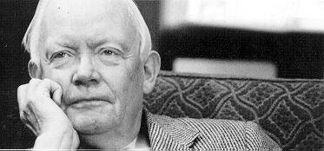Psychology

After the NAMBLA site goes through the history of the organization and talks about famous figures, it digs into the Psychology of it. Above you will see a picture of Dr. Edward Brongersma who was a proponent of inter-generational relationships and author of the book Loving Boys. His book talks about how in ancient Greece/Rome, men that engaged in relationships with younger boys were held in high esteem. In other cultures such as the Indian or Arab times, it was frowned upon, yet when Christians came of power this type of relationship was seen as one that someone would be killed for. Not necessarily because it harmed the little boy and the age difference involved, but because of the homosexuality of such relationships. A new study suggests that sex between a man and a boy doesn’t create psychological damage. [The “meta-analysis” study combines over 50 studies and was published in the American Psychological Association]. It suggests that sex with minors isn’t as bad as what lawmakers/police/society make it out to be and talks about the correlation with sexual abuse vs. adjusting to life. Sexual abuse at an early age will not have any impact on a male child adjusting to later phases in adult life when it is consensual, whereas females did show some correlation.

Science and Social Research

Science and Social research is the tab directly under the Psychology portion of the web page. It digs deeper into the psychological aspects and goes through countless studies as to why NAMBLA believes a man/boy relationship shouldn’t be frowned upon. One link goes on to compare humans with their intelligent creature (dolphins) counterparts, suggesting homosexuality is normal across species.

The science also speaks about how they encountered sexual encounters between younger dolphins with their more mature adult dolphins. This would suggest that other species are not only homosexual, but also have relationships across generations. Another comparison is with warrior societies such as Sparta and Crete, where young boys were captured during the course of battle and subjected to initiations by older warriors of the tribe. These relationships were believed to be of homosexuality as well as cross generational and the author uses these two examples, among others, to negate the idea that homosexuality is not normal and only occurs with overpopulation of civilizations. These relationships occurred when overpopulation didn’t exist hundreds of years ago, as well as in the ocean where space is plentiful. Sifting through the countless studies, the website goes on to list several conclusions with the corresponding studies directly below the idea involved. They are as follows:

1. Most sexual contacts between boys and older partners are consensual, in academic terms they are not forced or coerced.

2. Boys who have sexual contacts with older partners usually feel the experience was harmless or beneficial.

3. Boys who have sexual contacts with older partners usually don’t feel negatively about the experience

4. Many boys who have sexual contact with older partners report strong positive feelings about the experience.

5. Boys who have non-coerced sexual contacts with older partners are not psychologically less adjusted than other males.

6. The degree of consent is largest factor in whether negativity will affect psychological adjustment.

7. The age at which someone has sexual experience is not a useful predictor of adjustment.

8. Men who love boys cannot be distinguished from other men on standard personality inventories and other psychological tests.

Cross Cultural Studies

After the Science and Social Research portion of the website, the next tab goes into the cross-cultural studies that can help shed light on the subject. It refers to different books, poetry, and other literature that can be compared to man/boy love. The book “Japanese Romance” talks about what may have been one of the most successful relationships/affairs that history ever encountered. Poetry written by Abu Uwas states his ideas on the subject and a portion of it talks about the passion that some share.

“Never before in real life nor art, have I found one so beautifully slender, so thin you might almost disappear if I couldn’t see you shining” and goes on to say “but my speech tinged his cheeks with pink blush, as if my words were splashes of dye”. In this portion of the web page, NAMBLA is showing the applicability across various cultures and sites anything from Japanese to Arabian authors when looking at different works of art.

Fine Arts (Literature, Music, Poetry, etc…)

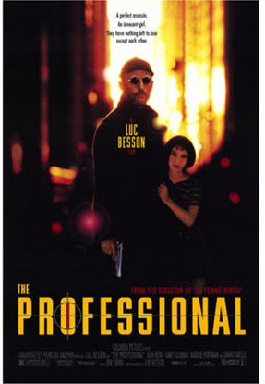The last few links get into the fine arts and include anything from literature, music, poetry, and current film/television. There is a finely written paper explaining the detail as to why the author believes that [Harry Potter may have been involved with Ron Weasley in a loving relationship]. It also had different ideas on why the movie “Stand By Me” is a good example of a love that two boys may have, taking out any generation aspects. River Phoenix, a famous actor, works opposite of Wil Wheaton in this flick where River’s character show the compassion and sensitivity that one must possess in order to “stand by” Wil Wheaton’s character that has a gift for creating stories. The two have a loving relationship minus the sexual penetration involved in such films as “Brokeback Mountain”. One other film that makes its way into the site is a movie called “The Professional”. This movie is said to have a “fresh view of intergenerational relations”. It was believed that the original character involved was that of a young boy, but in fear of not being distributed in the U.S. along with other areas, it was cast instead as a young girl. The young girl cast in the movie was played by Natalie Portman, which the site claims is a “must see” for man/boy lovers.

***Personal Autonomy and Consent***

When looking at consent, the classic sense of the word means to be “in agreement with”. This also consists of having the personal autonomy to be fully competent to make this decision. The law argues that society members under a certain age don’t possess the competence to enter such a contract, therefore the contract that they are in agreement with is null to begin with. NAMBLA must fight both the *mala prohibita* and the breakage of a social contract that didn’t exist to begin with, as well as the *mala in se* aspect that states the applicability of evil on persons. The uphill battle they face must first start with the definition within the currently established laws as to whom is competent to enter such agreements/contracts, as well as the bloodshed and evil that may come out of it.

**Conclusion**

The North American Man Boy Love Association was established to bring support to relationships that consist of homosexual couples (male) that stem across generations. They hope to build an understanding of the issues they face (criminalization) and are in cooperation with other movements including the liberation of lesbians, gays, and feminists. The uphill battle they face is two fold as not only is sexual encounters with minors illegal, they must also fight the ideas of homosexuality as well. They make their case by relying on the history of such relationships in the past, and hope research that has been done on the subject will help see that love between men and boys may not have the consequences that society believes results from them. Fundamental reform of certain laws will need to be achieved in order to continue with their cause, most notably the laws defining what age one must possess in order to consent to sexual encounters. The NAMBLA website that we covered in this paper is very extensive and by no means is this paper all inclusive, as links upon links bring readers to countless threads on the subject. In no way is this paper meant to express our opinions in either direction regarding the relationships between men and boys, but we hope to shed light and educate society as ignorance brought forth by mainstream media tends to bury it.